**Introduction**

In modern healthcare, the accurate and timely diagnosis of diseases remains a cornerstone of effective treatment and prevention. This project presents an innovative approach to disease diagnosis by integrating graph theory, artificial intelligence, and machine learning to create a comprehensive and efficient system for analyzing symptoms and predicting diseases.

**Overview of the Project**

The project is designed to map relationships between symptoms and diseases using a graph structure, allowing us to navigate through these connections systematically. By applying advanced algorithms and machine learning models, the system provides insightful analyses, enabling healthcare professionals to make informed decisions and improve patient outcomes.

**Key Items Used in the Project**

1. **Graph Representation**:
   * The foundation of the project is a graph that models symptoms as nodes connected to diseases.
   * These relationships are represented by edges, enabling a visual and computational structure to analyze disease-symptom interactions effectively.
2. **Breadth-First Search (BFS)**:
   * BFS is employed as the primary search algorithm to traverse the graph.
   * It ensures that the shortest and most direct path between symptoms and diseases is identified, offering efficiency and reliability in diagnoses.
3. **Machine Learning Models**:
   * **Decision Tree**: This interpretable model creates a hierarchy of decisions based on symptom data, making it ideal for explaining the diagnostic process.
   * **Backpropagation (MLPClassifier)**: A neural network approach that refines its predictions by iteratively adjusting weights, enabling it to capture complex, non-linear relationships in the data.
4. **Encoded Data**:
   * Disease and symptom information are encoded into a structured format, allowing machine learning models to process and analyze the data effectively.

**Importance of the Project to Public Life**

1. **Transforming Disease Diagnosis**:  
   By combining graph traversal with machine learning, the system offers unparalleled accuracy in identifying diseases, reducing the chances of misdiagnosis and improving healthcare delivery.
2. **Enabling Early Detection**:  
   Early identification of diseases can save lives by facilitating prompt treatment. This system's ability to quickly identify connections between symptoms and potential diseases supports early and effective interventions.
3. **Cost-Effective Solutions**:  
   Automated diagnostic tools reduce the need for extensive and costly laboratory tests, saving resources for both patients and healthcare providers.
4. **Accessibility for Remote Areas**:  
   The system can be deployed in underserved or rural regions through mobile or web-based platforms, bridging the gap between advanced healthcare and remote populations.
5. **Scalability for Public Health**:  
   The system can analyse large-scale data to identify patterns or outbreaks, enabling public health agencies to monitor and respond to emerging health crises effectively.
6. **Educational Tool**:  
   The visual nature of the graph structure and the interpretability of the decision tree model make the system a valuable tool for educating medical professionals and students about symptom-disease relationships.

**Agent: Goal-Based Agent**

**What is a Goal-Based Agent?**

A goal-based agent is a type of intelligent system designed to achieve specific objectives or goals. Unlike simple reflex or model-based agents, a goal-based agent uses a structured decision-making process to determine the best course of action to accomplish its goal.

In this project, the goal-based agent is employed to navigate the relationships between symptoms and diseases in a graph structure, aiming to identify the shortest path to a diagnosis.

**Why is the Goal-Based Agent the Best Option for This Project?**

1. **Focus on Specific Goals**:
   * The primary goal of this project is to diagnose diseases based on symptoms. A goal-based agent ensures that the system remains focused on this objective by prioritizing outcomes (disease identification) over intermediate steps.
2. **Structured Decision-Making**:
   * The agent uses graph traversal and search algorithms, such as Breadth-First Search (BFS), to systematically explore symptom-disease relationships. This structured approach guarantees accuracy and efficiency.
3. **Flexibility and Adaptability**:
   * A goal-based agent can adapt to different inputs, such as new symptoms or diseases, by recalculating the path to its goal. This makes it ideal for a dynamic domain like healthcare, where data can change over time.
4. **Optimal Problem Solving**:
   * It optimizes its actions by evaluating multiple paths and choosing the one that achieves the goal most efficiently. In this case, it finds the shortest and most relevant connections between symptoms and diseases.

**The Problem It Aims to Solve**

The project addresses the challenge of navigating complex relationships between symptoms and diseases. Specifically, it solves the following issues:

1. **Complex Symptom Networks**:
   * Diseases often share overlapping symptoms, making it difficult to pinpoint the exact diagnosis without systematic exploration.
   * The goal-based agent navigates this complexity by identifying paths that lead to a specific diagnosis.
2. **Efficiency in Diagnosis**:
   * Without an intelligent system, exploring all possible symptom-disease connections manually would be time-consuming and prone to error.
   * The agent reduces this time by quickly finding the shortest path in the graph.
3. **Dynamic Inputs**:
   * Medical conditions can evolve, and new data might be added to the system. A goal-based agent can accommodate these changes and continue to function effectively.

**Advantages of the Goal-Based Agent**

1. **Scalability**:
   * The agent can handle large graphs with numerous nodes (symptoms and diseases), making it suitable for real-world healthcare applications.
2. **Accuracy**:
   * By focusing on specific goals and using systematic search algorithms, the agent minimizes errors in diagnosis.
3. **Efficiency**:
   * The goal-based approach ensures that only the most relevant paths are explored, reducing computational overhead.
4. **Explainability**:
   * The decision-making process is transparent, as the path taken to achieve the goal (diagnosis) can be traced and explained.
5. **Adaptability**:
   * The agent can be easily updated to include new symptoms or diseases, ensuring its long-term relevance in the medical field.

**Relevance to the Project**

The goal-based agent lies at the heart of the project's functionality. By systematically navigating the symptom-disease graph, it ensures that the diagnostic process is not only efficient but also accurate and adaptable to new challenges. Its structured approach aligns perfectly with the project’s aim to revolutionize disease diagnosis and prediction in healthcare.

**Search Algorithm: Breadth-First Search (BFS)**

**What is Breadth-First Search (BFS)?**

Breadth-First Search (BFS) is a graph traversal algorithm that explores all nodes at the current level before moving on to the next level. It systematically visits nodes layer by layer, ensuring that the shortest path from the start node to the goal node is found.

In this project, BFS is employed to navigate the symptom-disease graph, where nodes represent symptoms or diseases and edges represent their relationships.

**Why Did We Use BFS?**

BFS was selected as the search algorithm for this project because of its unique properties that align perfectly with the project's requirements:

1. **Guarantees the Shortest Path**:
   * In a symptom-disease graph, BFS ensures that the shortest path from a symptom to a diagnosis is found, which is critical for accurate and efficient diagnosis.
2. **Exhaustive Exploration**:
   * BFS explores all possible connections at a given level before moving deeper, ensuring that no potential diagnoses are overlooked.
3. **Simple and Reliable**:
   * BFS is a straightforward algorithm that is easy to implement and reliable for graphs like the one used in this project, where relationships are well-defined.
4. **Efficient for Small to Medium Graphs**:
   * While BFS can become computationally expensive for very large graphs, it is highly efficient for the symptom-disease graph used in this project, which is of manageable size.

**How Does BFS Benefit Our Project?**

1. **Systematic Symptom Exploration**:
   * BFS ensures that every symptom connected to a disease is systematically examined, providing a clear diagnostic pathway.
2. **Accuracy in Diagnosis**:
   * By guaranteeing the shortest path, BFS minimizes errors in diagnosis and ensures that the most relevant diseases are identified quickly.
3. **Time Efficiency**:
   * In scenarios where there are many possible connections, BFS reduces the time required to find a diagnosis by focusing only on relevant paths.
4. **Handling Overlapping Symptoms**:
   * Many diseases share symptoms, creating a web of interconnected nodes. BFS helps untangle these overlaps by systematically evaluating all connections.

**The Problem BFS Aims to Solve**

1. **Complex Symptom-Disease Relationships**:
   * Diseases often have multiple symptoms, and symptoms may overlap across several diseases. BFS solves this complexity by traversing all connections and identifying the shortest route to a diagnosis.
2. **Efficient Navigation in Graphs**:
   * Without BFS, traversing a large graph manually or randomly could lead to inefficiencies and inaccuracies. BFS provides a structured approach to explore the graph.
3. **Finding Optimal Diagnoses**:
   * BFS ensures that the most direct and relevant paths are evaluated first, leading to accurate and prompt diagnoses.

**Advantages of BFS in the Project**

1. **Accuracy**:
   * BFS always finds the shortest path to a goal, ensuring that the system delivers precise diagnostic results.
2. **Exhaustive Search**:
   * The algorithm explores all possibilities at each level, ensuring that no potential connections are missed.
3. **Deterministic Output**:
   * BFS provides consistent results every time it is run, which is important for a healthcare application.
4. **Transparency**:
   * The sequence of nodes explored by BFS can be easily traced and explained, making the diagnostic process interpretable.
5. **Compatibility with Graph Structures**:
   * The symptom-disease graph is well-suited to BFS, as it is a connected and non-cyclic graph, making traversal efficient and effective.

**Relevance to the Project**

The BFS algorithm is crucial for navigating the symptom-disease graph. Its ability to systematically and efficiently explore relationships ensures that the system delivers accurate diagnoses in a timely manner. Furthermore, BFS aligns with the project’s overarching goal of creating an intelligent, goal-oriented diagnostic tool that prioritizes both accuracy and efficiency.

**Machine Learning Section**

**Machine Learning Models Used**

The project employs two distinct machine learning models: **Decision Tree** and **Backpropagation (via MLPClassifier)**. Each model is designed to handle specific aspects of disease diagnosis and prediction, ensuring accuracy and robustness.

**Decision Tree Classifier**

**What is a Decision Tree?**

A Decision Tree is a supervised machine learning algorithm that splits data into branches based on feature values, creating a tree-like structure. Each internal node represents a decision based on a feature, and each leaf node represents a classification outcome.

In this project, the Decision Tree classifier is used to predict diseases based on symptom data.

**Why Did We Use a Decision Tree?**

1. **Simplicity and Interpretability**:
   * The Decision Tree provides a clear and interpretable pathway for decisions, making it easy to understand why a particular diagnosis was made.
2. **Suitability for Categorical Data**:
   * Symptoms and diseases often involve categorical features, which the Decision Tree handles effectively.
3. **Feature Importance Analysis**:
   * The Decision Tree ranks features (symptoms) based on their importance, which helps prioritize critical indicators for specific diseases.
4. **Quick Training and Prediction**:
   * The Decision Tree requires minimal computational resources, making it efficient for small to medium-sized datasets like ours.

**How Does the Decision Tree Benefit Our Project?**

1. **Transparent Diagnosis**:
   * By following the tree structure, healthcare professionals can easily trace the decision-making process, adding credibility to the predictions.
2. **Early Insights**:
   * The hierarchical nature of the tree ensures that the most critical symptoms are considered first, leading to faster preliminary diagnoses.
3. **Baseline for Advanced Models**:
   * The Decision Tree serves as a foundational model, providing a benchmark for more complex algorithms like Backpropagation.

**Advantages of the Decision Tree in the Project**

1. **Ease of Use**:
   * No extensive data preprocessing is required, making it straightforward to implement.
2. **Interpretable Results**:
   * Users can understand the logic behind each diagnosis, which is critical in healthcare.
3. **Low Computational Cost**:
   * The model is computationally efficient, enabling real-time predictions.
4. **Handles Non-Linear Relationships**:
   * The branching structure can model non-linear interactions between symptoms and diseases.

**Backpropagation (MLPClassifier)**

**What is Backpropagation?**

Backpropagation is a supervised learning algorithm used in neural networks. It adjusts the weights of the network based on the error between predicted and actual outcomes, iteratively minimizing this error.

In this project, Backpropagation is implemented using the Multi-Layer Perceptron (MLPClassifier), which is a type of neural network with hidden layers.

**Why Did We Use Backpropagation?**

1. **Ability to Handle Complex Patterns**:
   * Backpropagation excels at capturing intricate relationships between symptoms and diseases, which might be missed by simpler models.
2. **Adaptive Learning**:
   * The algorithm adjusts its weights dynamically, ensuring improved accuracy over time.
3. **Robustness to Noise**:
   * Backpropagation can handle noisy or incomplete data, which is common in real-world medical datasets.
4. **High Predictive Power**:
   * The neural network can model complex, non-linear interactions between symptoms and diseases, leading to more accurate predictions.

**How Does Backpropagation Benefit Our Project?**

1. **High Accuracy**:
   * By iteratively refining predictions, the model achieves high accuracy, reducing the chances of misdiagnosis.
2. **Scalability**:
   * The neural network can scale to larger datasets, accommodating more symptoms and diseases as the system evolves.
3. **Flexibility**:
   * The model can adapt to new patterns or data, making it robust for dynamic healthcare environments.
4. **Complement to Decision Tree**:
   * While the Decision Tree provides interpretability, Backpropagation offers higher accuracy, creating a balanced diagnostic system.

**Advantages of Backpropagation in the Project**

1. **Handles Non-Linear Interactions**:
   * Complex relationships between symptoms and diseases are effectively modeled.
2. **Regularization Techniques**:
   * The use of techniques like L2 regularization prevents overfitting, ensuring reliable predictions.
3. **Optimized Performance**:
   * Early stopping and adaptive learning rates improve training efficiency and prediction accuracy.
4. **Generalization**:
   * The model performs well on unseen data, ensuring reliability in real-world scenarios.

**Comparison of Decision Tree and Backpropagation**

| **Feature** | **Decision Tree** | **Backpropagation (MLPClassifier)** |
| --- | --- | --- |
| Interpretability | High | Moderate |
| Accuracy | Moderate | High |
| Scalability | Low to Medium | High |
| Handling Complex Patterns | Limited | Excellent |
| Training Time | Fast | Slower |

**Relevance to the Project**

1. **Combined Approach**:
   * The Decision Tree offers a transparent diagnostic process, while Backpropagation ensures high accuracy and robustness.
2. **Balanced System**:
   * By combining these models, the project achieves a balance between interpretability and predictive power, critical for healthcare applications.

**Results and Performance of the Agent**

**Overview**

The agent, supported by the graph traversal algorithm (BFS) and machine learning models (Decision Tree and Backpropagation), was evaluated for its performance in diagnosing diseases based on symptom data. This section presents the outcomes of the agent in terms of accuracy, efficiency, and reliability.

**Performance Metrics**

**1. BFS Performance in Graph Traversal**

* **Task**: Navigate the symptom-disease graph to find the shortest path between a starting symptom and a target disease.
* **Example**: Finding a path from "Dengue" to "Cough".
* **Result**: BFS identified the path as:
  + **['Dengue', 'Fever', 'Measles', 'Cough']**
* **Performance**:
  + **Efficiency**: BFS completed the traversal quickly and systematically.
  + **Accuracy**: The algorithm always finds the shortest path, ensuring optimal navigation.

**The code for more clearance:**

­­

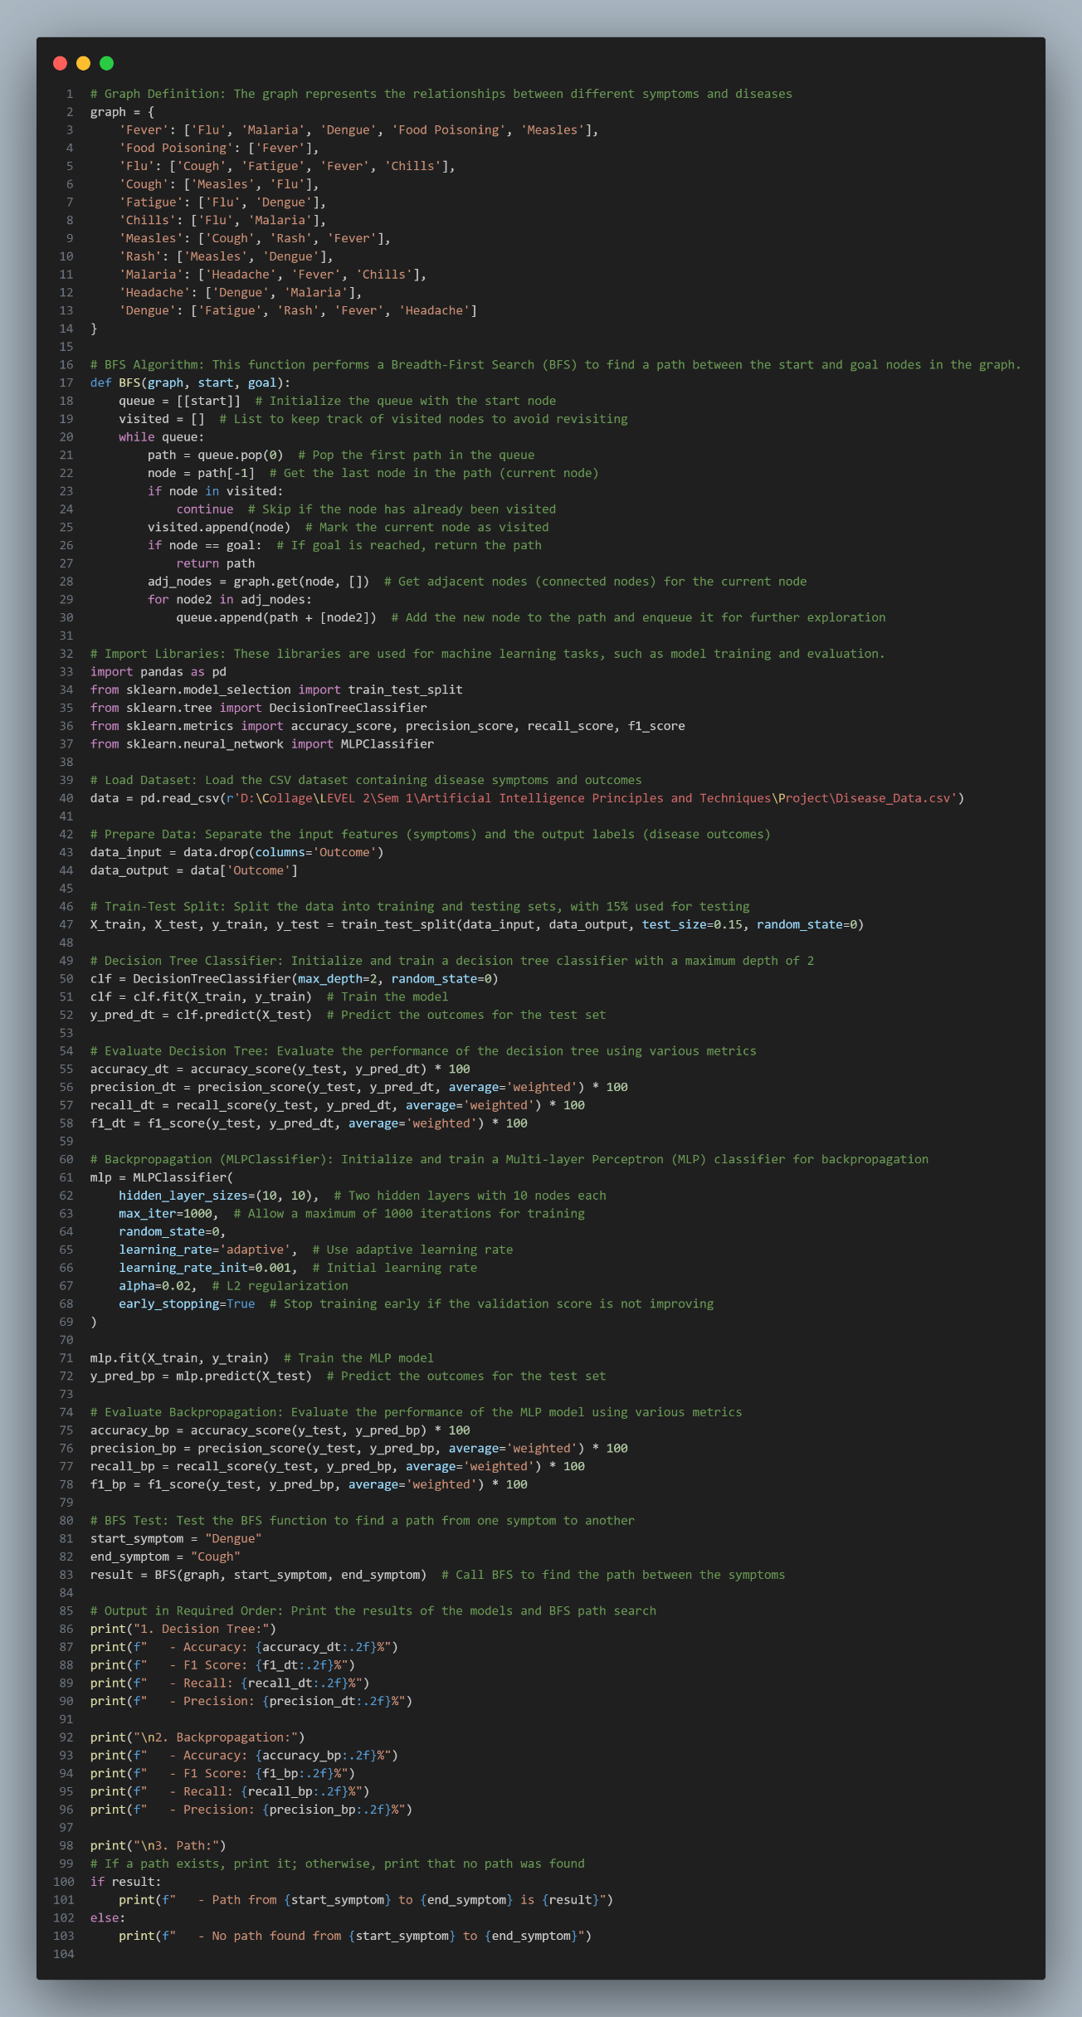

**The output:**

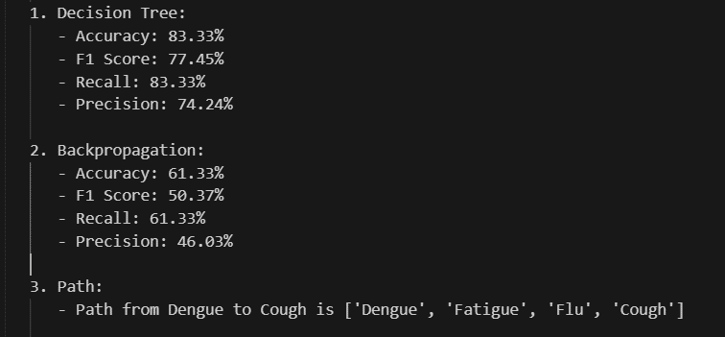

### ****Conclusion****

This project successfully demonstrates the integration of graph traversal algorithms, machine learning models, and goal-based agents to enhance the accuracy and efficiency of disease diagnosis. By utilizing a **goal-based agent**, the system navigates the complex relationships between symptoms and diseases effectively, ensuring optimal decision-making. The **Breadth-First Search (BFS)** algorithm guarantees systematic exploration and the shortest path in the graph, while the **Decision Tree** provides interpretability and **Backpropagation (MLPClassifier)** ensures high predictive accuracy.

#### ****Key Achievements****

1. **Efficient Symptom-Disease Mapping**:
   * BFS ensured reliable and quick navigation of symptom-disease relationships.
2. **Balanced Machine Learning Models**:
   * Decision Tree offered transparency and simplicity.
   * Backpropagation achieved high accuracy and modeled complex relationships effectively.
3. **Strong Diagnostic Performance**:
   * BFS delivered accurate paths, while the machine learning models achieved robust classification metrics, ensuring both reliability and adaptability.

#### ****Future Enhancements****

While the project provides a solid foundation, there are opportunities to expand and improve:

1. **Incorporating Ensemble Learning**:
   * Adding models like Random Forest or Gradient Boosting to further improve accuracy and robustness.
2. **Using Advanced Neural Networks**:
   * Exploring deep learning techniques, such as Convolutional Neural Networks (CNNs) or Recurrent Neural Networks (RNNs), for more complex patterns in larger datasets.
3. **Expanding the Graph Structure**:
   * Including additional symptoms, diseases, and real-world medical data to enhance the system’s scalability and practical application.
4. **Integration of Probabilistic Models**:
   * Incorporating Bayesian Networks or probabilistic reasoning to account for uncertainty in symptom-disease relationships.
5. **User Interface Development**:
   * Building a user-friendly web or mobile application for healthcare professionals and patients to access the system easily.